Grade 2 Grammar & Conventions Expectations

Grammar
- Identifies nouns, verbs, adjectives, and adverbs in general and their functions in particular sentences.
- Use the simple verb tenses (e.g., I walked; I walk; I will walk).
Punctuation
- Capitalize proper nouns. 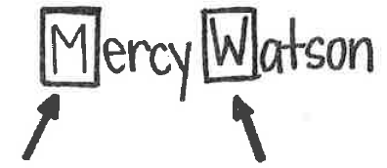
- Use commas and apostrophes appropriately.
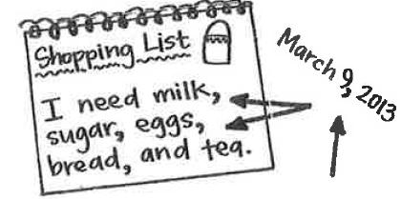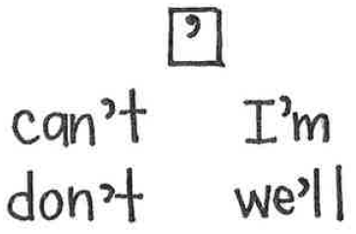
- Use quotation marks around the speaker’s exact words.
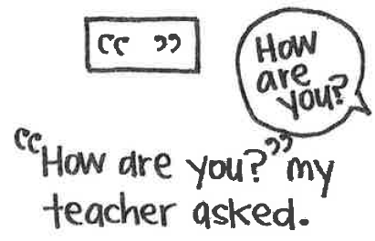
Spelling
- Spell words drawing on common spelling patterns.
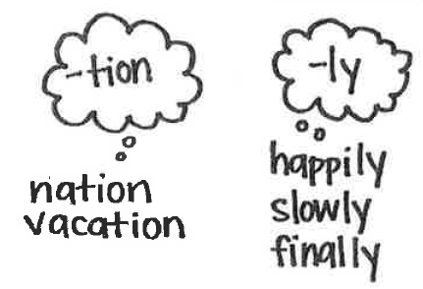
- Consult reference material as needed.
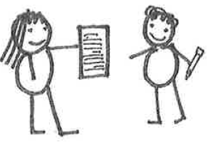
- Spell word wall words correctly.
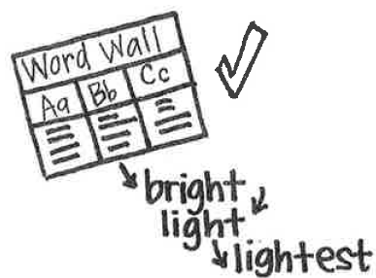
Editing/Revising
- Choose words and phrases for effect.*
